**Environment setup for JavaFX Project**

* Install Java JDK and JRE. Set the path in Environment Variable.
* Install IntelliJ IDE and make following settings to the project.

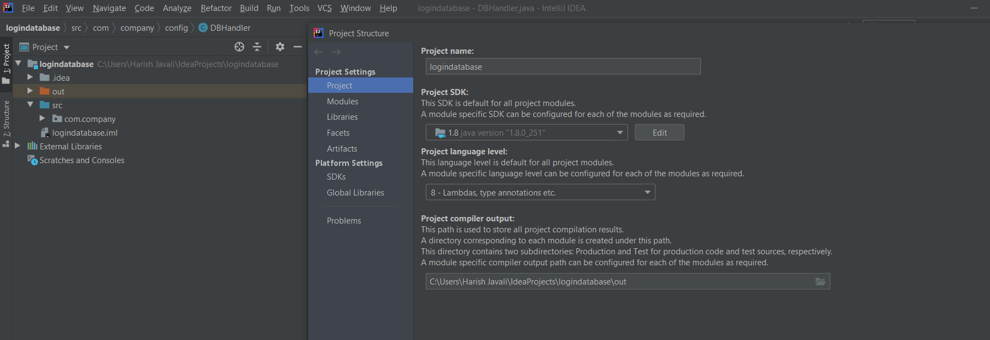

* Set Target bytecode version to 8.

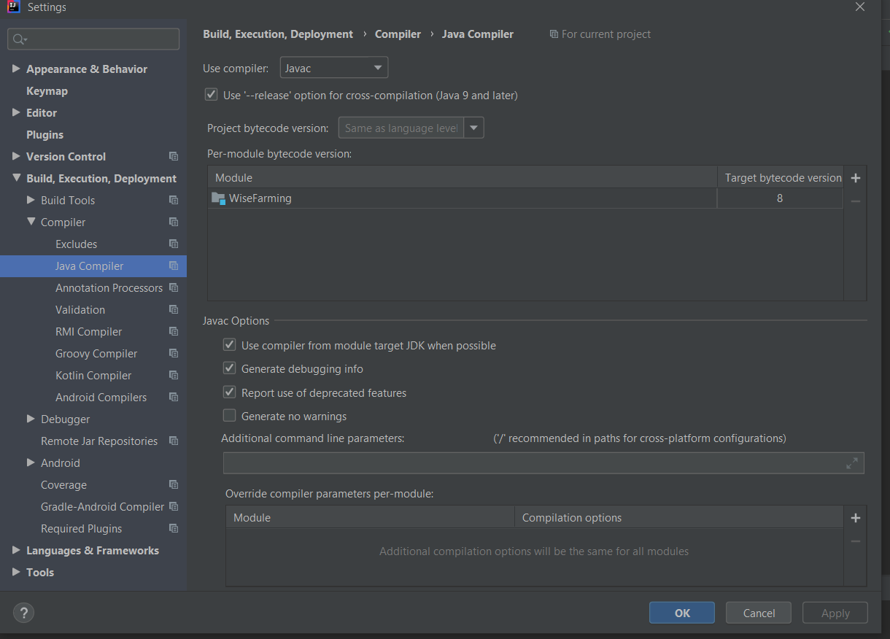

* Install MySQL and set path in Intellij IDE.

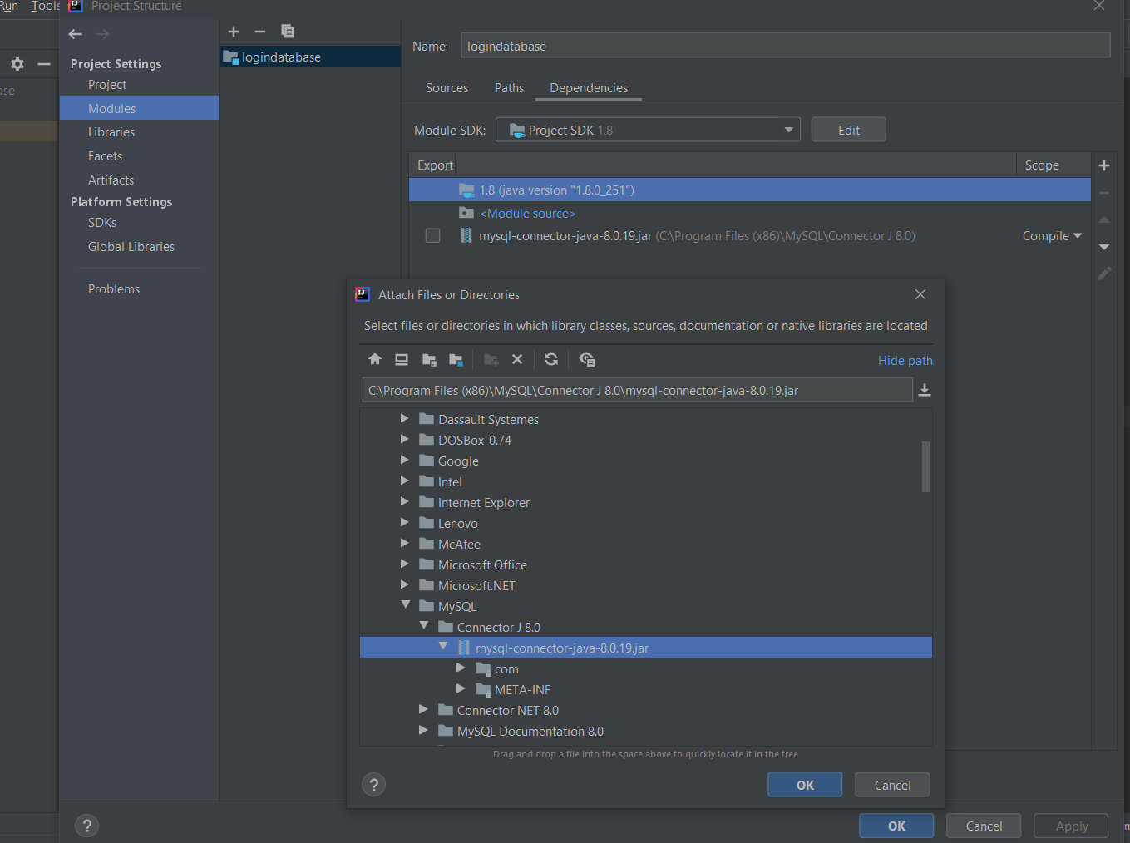

* Download JFoenix and setpath.

